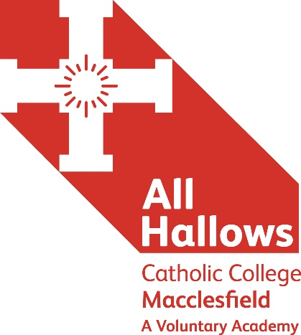
EXAM INVIGILATORS

Hourly rate of £8.75 Flexible hours

We are seeking to appoint Exam Invigilators to assist with primarily November, January and May/June Public Exam Seasons

The ideal candidate will have a flexible approach, have effective verbal and written communication skills and be confident with a reassuring presence to candidates in exam rooms. Training will be provided to ensure all standards are met and maintained throughout the exam period.

Main duties are as follows:
To conduct examinations in accordance with JCQ, awarding body and All Hallows instructions.

Before exams
- To report to the Exams Officer prior to each exam session
- To keep exam papers and materials secure at all times
- To ensure exam rooms are set out to standard
- To identify, seat, and instruct candidates in the conduct of their exams
- To distribute exam papers and materials to candidates
- To deal with candidate queries

During exams
- To supervise candidates at all times and be vigilant throughout exams
- To keep disruption to a minimum
- To deal with emergencies or irregularities effectively
- To record/report any irregularities
- To complete attendance registers

After exams
- To collect exam scripts
- To dismiss candidates from the exam room
- To return exam scripts and other materials to the exams officer

Other
- To attend training, refresher or review sessions as required
- To undertake, where required and where able, other duties requested by the exams officer.

Application documents can also be found on the Catholic Education Service website: http://www.catholiceducation.org.uk/
Please go to: Employment Documents / Application Forms
You are required to complete the following documents:
Support Staff Application Form / Recruitment Monitoring Form / Rehabilitation of Offenders Disclosure Form
All posts are offered subject to agreement to sign the CES contract of employment with the Holy Family of Nazareth Catholic Academy Trust and enhanced DBS clearance suitable for working with children and young adults.

Applications to the HR Office at:
All Hallows Catholic College, Brooklands Avenue, Macclesfield, Cheshire SK11 8LB
Or via email to: hr@allhallows.org.uk

‘Aspire not to have more, but to be more’
Blessed Oscar Romero
☩ Honourable purpose ☩ Respect ☩ Compassion ☩ Cooperation ☩ Stewardship ☩

A Member of The Holy Family of Nazareth Catholic Academy Trust

